Project Sprint #1

GitHub Repository:
https://github.com/Charles-oak/cs449-peg-solitaire

The Solitaire game is described in CS449HomeworkOverview. You should read the description very carefully.

In this assignment, you aim to specify the requirements (i.e., user stories and acceptance criteria) of the target software that allows a human player to play a Solitaire game. These requirements will be fully implemented by the end of sprint 3. The minimum features include choosing the board size and type, starting a new game, making a move, determining if a game is over. The following is a sample GUI layout.

Board size
7
Board Type  - English  - Hexagon  - Diamond | 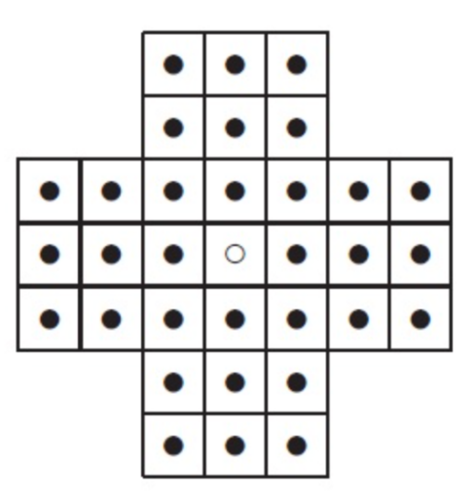 | New Game
Figure 1. Sample GUI layout of the first working program by the end of Sprint 3

Use the following tables to document your user stories and acceptance criteria.

You are required to use the free ChatGPT or another LLM to complete two user stories and two of their respective acceptance criteria. You must ensure that the generated user stories are correct and fix them if not. At the end of the submission, provide screenshots of your LLM prompts and answers, along with the description of errors the LLM made that you had to correct. Points will be deducted if no screenshots/description are provided.

For the other user stories and acceptance criteria, you are not required to use LLM.

- User Stories (3 points)

- User Story Template: As a <role>, I want <goal> [so that <benefit>]

ID | User Story Name | User Story Description | Priority | Estimated effort (hours)
1 | Choose a board size | As a human player, I want to choose the board size so that I can adjust the complexity of the game to my preference. | Medium | 2
2 | Choose the board type | As a human player, I want to choose a board type so that I can play Solitaire using the board layout I prefer. | Medium | 2
3 | Start a new game of the chosen board size and type | As a human player, I want to start a new game using the selected board size and board type so that I can begin playing with my chosen settings. | High | 4
4 | Make a move in a game | As a human player, I want to make a valid move so that I can progress toward completing the game. | High | 5
5 | A game is over | As a human player, I want the system to determine when the game is over so that I know when play has ended and can see my result. | High | 4

II. Acceptance Criteria (AC) (12 points): Add/delete rows as needed.
User Story ID and Name | AC  ID | Description of Acceptance Criterion | Status (completed, toDo, inPprogress)
1. Choose a board size | 1.1 | AC 1.1 Select a valid board size  Given the player is on the game setup screen.  When the player enters a supported board size.  Then the system accepts and saves the selected size for the next game. | toDo
1. Choose a board size | 1.2 | AC 1.2 Reject an invalid board size  Given the player has already selected a valid board size.  When the player enters an invalid or unsupported board size.  Then the system displays an error message, rejects the invalid input, and preserves the previously selected valid board size. | toDo
2. Choose the board type | 2.1 | AC 2.1 Select a board type  Given the player is on the game setup screen.  When the player selects English, Hexagon, or Diamond.  Then the system saves the selected board type for the next game. | toDo
2. Choose the board type | 2.2 | AC 2.2 Change the selected board type  Given the player has already selected a board type.  When the player selects a different board type.  Then the system updates the selection, and only the newly selected board type remains selected. | toDo
3. Start a new game of the chosen board size and type | 3.1 | AC 3.1 Initialize a new game  Given the player has selected a valid board size and board type.  When the player clicks the New Game button.  Then the system creates and displays a board of the selected size and type, with the central hole empty and all other playable positions filled with pegs. | toDo
3. Start a new game of the chosen board size and type | 3.2 | AC 3.2 Restart an existing game  Given the player has already started a game.  When the player clicks the New Game button.  Then the system resets the game and initializes a new board using the currently selected size and type. | toDo
4. Make a move in a game | 4.1 | AC 4.1 Make a valid orthogonal move  Given a peg has an adjacent peg horizontally or vertically and an empty hole two positions away.  When the player moves the first peg into the empty hole by jumping over the adjacent peg.  Then the system accepts the move, removes the jumped peg, empties the starting position, and places the moving peg in the destination hole. | toDo
4. Make a move in a game | 4.2 | AC 4.2 Make a valid diagonal move  Given a peg has an adjacent peg diagonally and an empty hole two positions away in the same direction.  When the player moves the first peg diagonally over the adjacent peg into the empty hole.  Then the system accepts the move, removes the jumped peg, and updates the starting and destination positions. | toDo
4. Make a move in a game | 4.3 | AC 4.3 Reject a move with an invalid board state  Given the starting position is empty, the jumped position is empty, or the destination is occupied.  When the player attempts to make the move.  Then the system rejects the move and leaves the board unchanged. | toDo
4. Make a move in a game | 4.4 | AC 4.4 Reject an invalid movement path  Given the player attempts a move that is not a permitted two-position orthogonal or diagonal jump, or that leads outside the board.  When the player attempts the move.  Then the system rejects the move and leaves the board unchanged. | toDo
5. A game is over | 5.1 | AC 5.1 End the game with one peg remaining  Given the player has completed a move and only one peg remains on the board.  When the system checks the current game state.  Then the system declares the game over and displays an Outstanding rating. | toDo
5. A game is over | 5.2 | AC 5.2 End the game when no valid moves remain  Given more than one peg remains on the board and no valid moves are available.  When the system checks the current game state.  Then the system declares the game over and displays the result based on the remaining number of pegs: Very Good for two, Good for three, or Average for four or more. | toDo

Summary of LLM Errors and Corrections:
I used ChatGPT to generate User Stories 1 and 4 and their corresponding acceptance criteria. After reviewing the generated content, I identified several issues.
For User Story 1, the original benefit simply repeated the goal of choosing a preferred board size, so I revised it to explain that players can adjust the complexity of the game to their preference. For User Story 4, the original description included detailed movement rules that belong in the acceptance criteria, so I simplified it to focus on the player's goal of progressing toward completing the game.
I also reviewed the generated acceptance criteria. Those for User Story 4 were correct and did not require changes. However, AC 1.2 did not specify what should happen to a previously selected valid board size when the player enters an invalid value. I requested a revision to ensure that the system rejects the invalid input while preserving the previous valid selection.

Screenshots of your LLM prompts and answers:

